*BARBIER Juliette, DE GAULEJAC Timothée, LIS Anastasiya, MENEGUZZO Sorenza*

*TOULOUSE BUSINESS SCHOOL | Big Data, Marketing and Management*

*ALEXA from amazon*

Text Analytics

TABLE OF CONTENTS

INTRODUCTION 2

I- DISCOVERY 2

A) Business field 2

B) Problem 2

C) Hypotheses 2

II- DATA PREPARATION 3

III- MODEL PLANNING AND BUILDING 3

A) Exploratory analysis 3

B) Sentiment Analysis 6

C) Words frequencies 12

V- RESULTS 13

# INTRODUCTION

Amazon was founded by Jeff Bezos in July 1994. It’s an American online retail company based in Seattle. It is part of one of the giants of the Web, GAFAM, alongside Google, Apple, Facebook, and Microsoft. Amazon's initial business was in distance selling of books, before the company diversified into the sale of cultural products, then merchandise and finally the Iot.

Amazon, like its competitors, is responding to the demands of its customers regarding the emergence of new technologies. Therefore in 2014 the company launched Alexa and ECHO. Alexa is the name that designates and is used to address the intelligent personal assistant developed by Amazon. This device is capable of voice interaction, playing music, making to-do lists, setting alarms, playing podcasts and audiobooks, and giving weather, traffic, and other real-time information. Alexa can also control multiple smart devices by acting as a home automation hub.

# I- DISCOVERY

## Business field

Voice assistants like Amazon’s Alexa, are present and used in many areas such as customer relationship, artificial intelligence (AI), and especially voice technology, bring major innovations in the retail and e-business sector business, offering a completely new user experience (UX). The customer’s interest is not to have to navigate the different categories or “shelves” of a store, nor to sift through dozens of pages to find the ideal product. The voice assistant acts as a real sales advisor. Banks, financial companies, and insurance services have actively adopted company voice assistants, both for their employees and especially for their clients. These virtual assistants sometimes take the place of financial advisors to guide account holders in their efforts. Reducing the burden on those working for companies is one of the challenges facing voice assistants.

## Problem

Amazon is planning to produce a new improved model of Alexa and they want to adjust it to the needs of their customers by producing the model which will lack the flaws/drawbacks it has had before. That’s why Amazon gave an assignment to their team of data analysists to conduct the sentiment analysis of the reviews on Alexa people left in the comments on Amazon to find out what people think about it.

## Hypotheses

One of the hypotheses that we made is that all the current customers are quite satisfied with the current Alexa. So, for the new Alexa, it can be based on what has been done and improve and fix the different bugs/problems that exist on the current model.

# II- DATA PREPARATION

To prepare our data, we used the ELT method: Extract, Load and Transform. We first extract our dataset, then we load it on RStudio so we can transform and clean it. Before analyzing the data, we first, had to clean it. First, we removed all the punctuation that is not useful for our analysis. Then, we removed all the words linked to Alexa that are not important for our analysis such as “Alexa”, “alexa”, “Amazon”, “amazon”. Furthermore, we removed all the stopwords that can distort our analysis. Finally, we put all the text in lowercase, we removed all the additional empty spaces, and also removed the lines that were duplicated.

# III- MODEL PLANNING AND BUILDING

We chose to use the “Text Analytics” model because it was the one that makes more sense since we wanted to see the customer satisfaction of the current Alexa to improve it for the new version.

To analyze our dataset, we used 3 different methods: the exploratory analysis, sentiment analysis, word association, and the words frequencies.

## Exploratory analysis

The first step of our analysis should start from an exploratory analysis to better understand the dataset. In the dataset we have 3150 observations of 5 variables that provide an overview of different Alexa products. And the first thing we need to find out is for which Alexa products we do have the reviews in the dataset which can be done by using *dplyr* package and grouping the dataset by the variable “variation”. But before that we will check if there are any duplicated rows in the dataset and remove them. As a result, the number of distinct rows was reduced to 2435 observations. Now let’s move to exploratory analysis.

From the screenshot we see that in the dataset we have reviews for 16 Alexa products and the highest number of them is for the Configuration.

Before analysing the reviews, it would be interesting to get a general overview of the opinions of the users by looking at the ratings. We can look at a bar chart of the ratings.

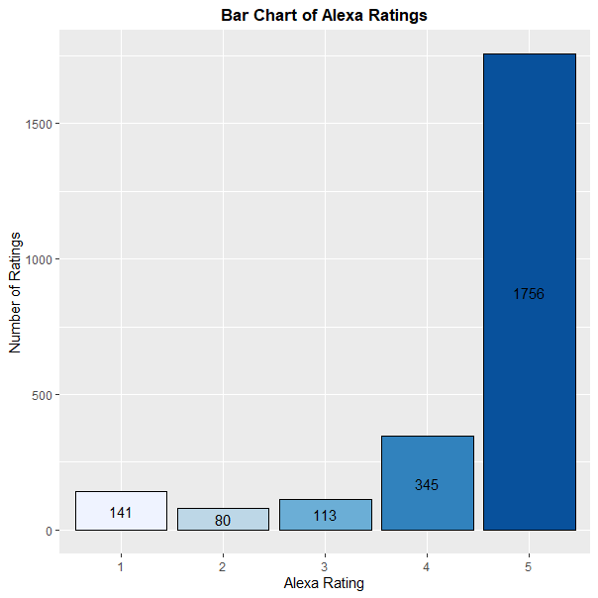

Most reviews are five-star rated and there are a few one-star rates, we can conclude that the general opinion is positive.

Now let’s analyze the reviews in depth. The first thing we do is loading the data as a corpus and cleaning it.

After cleaning the text data, we can count the occurrence of each word, to identify popular topics. Here, we are using the function “*TermDocumentMatrix()”* and building a term-document matrix.



After building a matrix, we can sort the words by the 50 most frequent words. But we see that there are some words that interfere with our analysis and don't bring any importance, that's why we need to remove them. So, we add the line of code deleting the following words ("music","speaker", "dot","device", "devices", "product", "can", "one", "use" , "just", "get", "still", "bought", "will","really","even","far","also").

Now we again can sort the words and display 20 most frequent words by plotting a bar chart.

We can interpret the following bar chart in the way, that it seems, that there are mostly positive words among the most frequent words like “love”, “great”, “like”, “easy”, “good” etc. But other words like “sound”, “home”, “quality” we cannot identify as positive or negative without the context.

As a next step, we can generate a word cloud by visualizing positive and negative sentiments of frequently occurring words using the “bing” sentiment lexicons and the *wordcloud* package.

From the wordcloud we can highlight some negative words which stand out of the mass, they are "alarm”, “problem”, “disappointed”, “issues”, “hard”, “difficult” and so on. Most of these words just describe a feelings people have about the product, but since our main objective is to distinguish the drawbacks that people find in Alexa products and give recommendations on how to improve future models, we cannot make any conclusion based on this wordcloud. Thus, let’s move to a deeper analysis of the reviews – sentiment analysis.

## Sentiment Analysis

The objective of the sentiment analysis will be to determine the amount of positivity and negativity in the reviews to have a general feeling of the users towards the product. We want to know if the users have a good or a bad opinion of Alexa. This analysis could also help us to know the strengths and the weaknesses of the product.

The sentiment analysis will analyse the words included in the sentences and tell if the words have a pejorative or meliorative connotation and the intensity of this connotation. Then it will give us a positive or negative number that reflects a positive or a negative opinion. The closer it is to 0, the more neutral the sentence is considered.

To begin with, we will generate a table with the sentiment score of each review and add it into a new dataset “reviews_new”.

We can see that the first comment has an average sentiment of 0.433 and that the third sentiment has a sentiment of -0.105.

But we don’t want to look at the reviews one by one and we would rather have a general overview.

Let’s see the overall sentiment graphically:

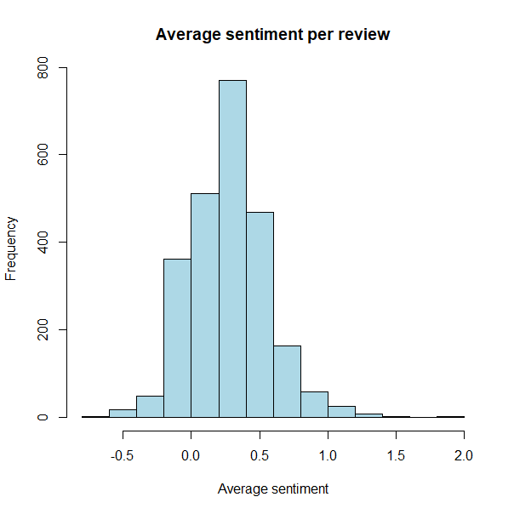

The overall sentiment is positive with a mean of 0.28. The users have a good impression of Alexa and wrote rather positive reviews.

Now, we want to go deeper and analyse the texts written by the users to see if it reflects the rating we have.

We can see the most frequent words appearing in the reviews with a positive or negative connotation, regardless of topic.

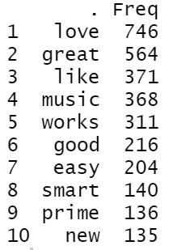 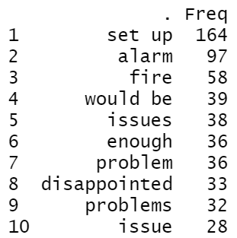

As you can see, "love" is most frequent positive term. Furthermore, the top ten words are all positive reaffirming that Amazon Alexa continues to be a great set of products. Only the word “music” seems more neutral than a positive expression.

As for the negative words, they appear generally less than the positive expressions. “Issue”, “problem” are coherent for their sentiment score being negative but “alarm” is more questionable as people might be talking about Alexa’s alarm in general without having an opinion about it. Without more analysis, we cannot determine if Alexa's alarm is good or bad. At most, we can highlight that people mention it in their reviews.

Let’s start the “Alarm” sentiment investigation

First, we can look at a small sample of the reviews that specifically mention "alarm" in the review.

The reviews don’t seem very negative and some of them are actually very positive concerning both Alexa product and Alexa’s alarm.

If we want to see the alarm’s defaults according to the users, we must filter the reviews by ratings. If we only care about one-star and two-star ratings, then we will be able to see if the alarm is considered as a bad aspect of the product.

Words like “disappointed”, “problem”, “terrible” appear regularly in the negative reviews but they don’t give any advice concerning the amelioration of the alarm. However, some words demonstrate a specific problem that could be linked to the alarm system.

We cannot be sure that these problems are related to the alarm, but we know that in the same review, both words were mentioned. We would need to read all the reviews to claim that the alarm is having specific problems. Still, we can assume that the alarm system is having “interferences”, problems with the “noise”, and is “annoying”.

Amazon could study this feature to adjust the volume and the hearing comfort for its user, but we will let them study this case deeper if needed.

Since we know the most frequent negative words, we can try to determine which words occur most often in association with these negative words. Thus, we can run a *Word association analysis* which helps to see the context around these words.

findAssocs(clean_reviews_dtm, terms = c("issues", "issue", "problems", "problem", "disappointing", "difficult", "limitations"), corlimit = 0.30).

This script shows which words are most frequently associated with such negative words as "issues”, “issue", "problems", "problem", "disappointing", "difficult", "limitations", (corlimit = 0.30 is the lower limit/threshold we have set). We use these words to get a context of the issues or problems people usually face when using Alexa devices.

Let’s start analyzing the output of the first 2 words “issue” and “issues”.

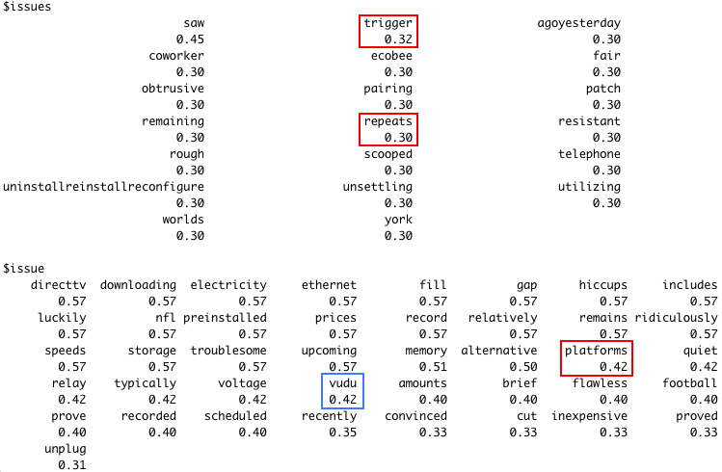

We have a lot of words in the output, and most of them don't really indicate a flaw, even if they occur in the same review with the selected negative word. But let’s check only the most interesting words. For example, let’s look closer at such words as “trigger” and “repeats” which occur 30-32% of the time with the word “issues” which might indicate on some problem. To better understand what that might mean and how these words are correlated, we can look for reviews which contain any of these words.

*reviews %>% filter(str_detect(verified_reviews, 'trigger|repeats'))*

Thus, it seems like Alexa devices can be activated sometimes even without trigger words which users find unsettling, and in some cases, users need to repeat their request a few times for Alexa to get their request (White Plus device). Moreover, there is a problem with reminders, which sometimes are too late or which sometimes trigger reminders by setting other reminders (Black Show model).

After checking the words which usually occur together with the word “issue” it seems like most of the words do not indicate a problem. The only flaw detected is not all the viewing platforms (for example, Vudu) being available through Amazon.

The next word association we will review is with words “problem” and “problems”.

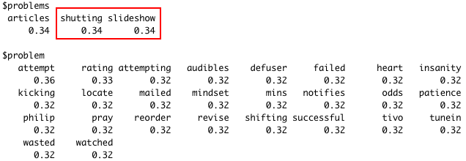

It seems that in 34% of cases “shutting” and “slideshow” appears with “problems”. After looking for comments with these words, we found that there is a problem with a screen presenting a slideshow of pictures, which just stops on the first picture and does not go further. Additionally, there is a problem with shutting down the device (Black Show model). While no interesting occurrences with word “problem” are spotted.

When checking associations with the word “disappointing”, only one word - “flickering” pointed out the problem which is the screen is starting flickering at some point in time (Black Show model).

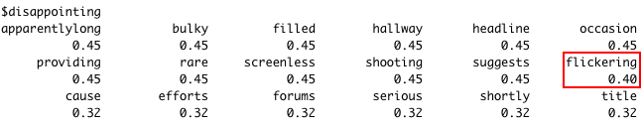

The next word is “difficult” and after reviewing the comments with the words which appear in 30% of cases with “difficult”, we found out that most of these words such as “failing”, “screw”, “swiping”, “touching”, “dismiss”, and “swipe” are connected to a problem with alarm. Users have problems turning off the alarm due to the difficulty to make a right “swipe” move. It seems that to dismiss the alarm it should be swiped, but it might be hard to make a swiping move in the morning so not the right swiping can be considered as a touch which results in setting snooze.

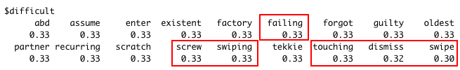

We also decided to look for an association with the word “limitations" to understand in which cases users face restrictions.

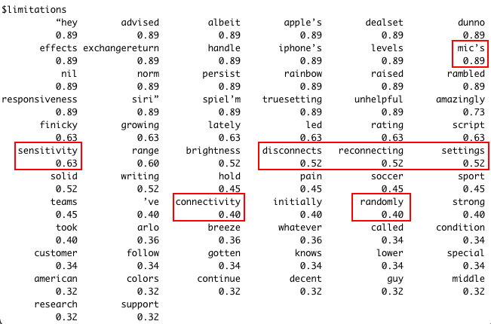

The word “mic” stands in this case for “microphone” and pinpoints the extremely popular problem with the sensitivity of the microphone in the Black, White Spot, Black Spot and Black Show models.

In addition, there are a lot of associations with words “disconnects”, “reconnecting”, “randomly”, “connectivity” which highlights one more exceedingly frequent problem with the devices disconnecting quite often from the internet. Such problem is a common for the following models: Black, White Spot, Black Spot, White Plus, Configuration: Fire TV Stick, Black, while the app shows that connection is strong.

We saw the most frequent positive and negative terms but analysing only words without context does not really help if we are interested in how the products could be improved.

It would be interesting to see a count of the top ten negative reviews to get a better understanding of why individuals gave poor ratings.

We are going to look at the extremes in terms of sentiment intensity. We want to know if some users had a really bad experience using Alexa and what are the weaknesses.

Here are the 10 most negatively charged reviews.

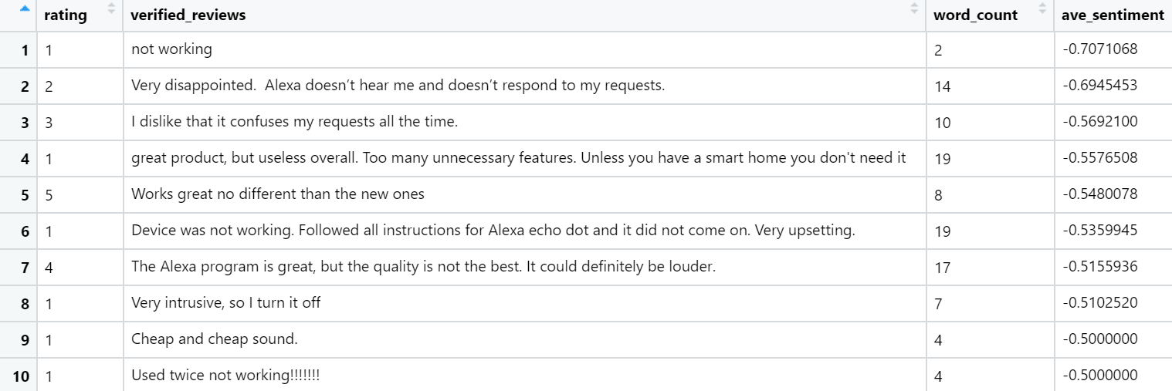

The worst average sentiment score is -0.71 with the comment “not working”.

We can notice some words that have probably influenced the score such as “disappointed”, “dislike”, “useless”. The ratings are usually between one or two, but we can see that there are some incoherent ratings with four and five-star ratings.

Still, the analysis seems coherent as most comments are negative.

According to comment 2 and 3, it seems that Alexa does not understand the user’s requests, comments 1, 6 and 10 are saying that the device is defective.

Now, let’s see the 10 most positively charged reviews to figure out the strengths of the product.

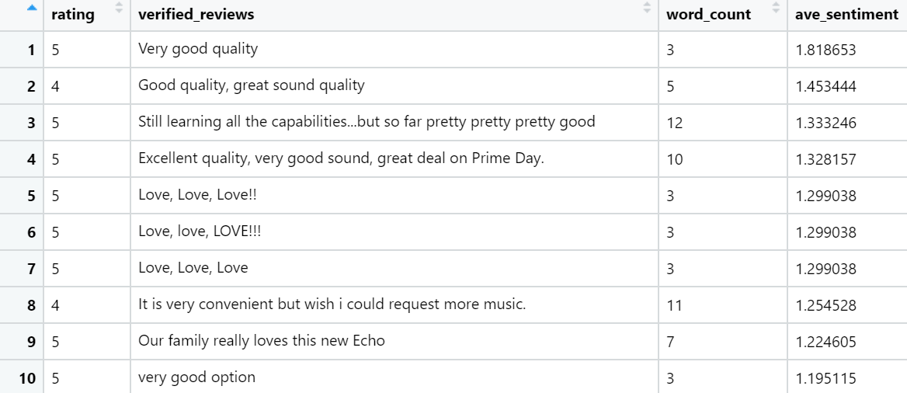

This time, the score is a lot different from 0 with a maximum of 1.82. Words like “good”, “great”, “love” are used in the reviews and the ratings seem coherent with the sentiment score as the ten reviews are rated as four or five.

We can notice that the number of words is weaker in this analysis than the negative analysis. People tend to write longer reviews when they have negative thoughts.

## Words frequencies

For the last part, we decided to analyse in more detail the frequency of the words. To do this, we first had to remove punctuation, symbols etc. Then we counted the words that were used the most. We can see that "Love" and "Great" are very frequent.

# Graph

ggplot(reviews[1:20,], aes(x=variation, y=rating)) +

geom_col() +

coord_flip() +

theme_minimal()

In order to deepen our analysis, we decided to highlight the link between the most frequent words and the number of documents in which they appear. We used the ggplot to create this graph and as you can see below, we notice that there is a strong coherence between the two factors.

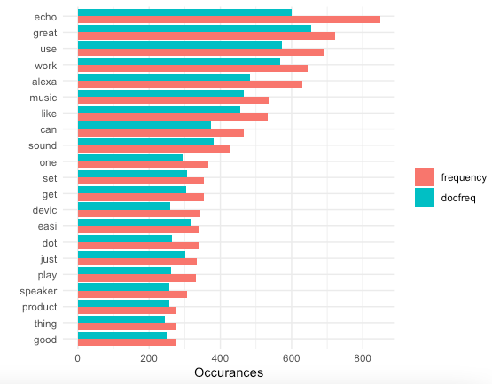

# V- RESULTS

To conclude, we can say that our result confirms our primary hypothesis: Alexa’s consumers are in general, very happy with their purchase.

However, when producing a new model Amazon could improve the reliability of its product and work on the response of the user’s requests by improving their algorithms. It is also possible that the users do not know how to use the product, then Amazon should have better explanations towards its product.

In addition, for the next Alexa, Amazon can improve the reminding system, the sensitivity of the microphone, and the connectivity with the internet that seems to be off a bit too often for some consumers.